**Instruction for Air Pollutant Estimation Toolbox and Example data**

***PM2.5:***

**Set workspace:** input a folder path to save output data

**Boundary:** input a path of polygon feature layer of study area. The study area of test data is Delhi (India). <https://github.com/datameet/Municipal_Spatial_Data/blob/master/Delhi/Delhi_Boundary-SHP.zip>

**NumberOfMosaicImages:** input how many satellite images will be mosaicked. In test data, Delhi is covered by 2 Landsat 8 images ---path146row40 and path147row40, so this parameter is 2.

**OutputFileName:** input an unoccupied folder name to store output raster file, this folder will be created under the path of workspace.

**Mosaic1_Metadata:** input text file path of the first satellite image metadata. Here it is the metadata of path146row40 Landsat 8 image, which was produced on Nov16,2017. <https://earthexplorer.usgs.gov/>

**Mosaic1_MonitorPoint:** input a path of point feature class which includes the location of each monitoring station and PM2.5 concentration ground truth data. Air pollutant ground truth data in most area of the world can be found at <https://aqicn.org/data-platform/register/>. Users should download the ground truth data and create point layer by themselves. The test data includes 15 monitoring stations in Delhi, PM2.5 concentration was measured on Nov16, 2017, which is same as satellite data.

**Mosaic1_band1image, Mosaic1_band2image, Mosaic1_band5image:** band 1,2,5 of the first Landsat 8 image. Test data are band1,2,5 of path146row40 image, produced on Nov16, 2017. <https://earthexplorer.usgs.gov/>.

**Mosaic2_Metadata:** input text file path of the second satellite image metadata. Here it is the metadata of path147row40 Landsat 8 image, which was produced on Nov23,2017. If users have only one satellite image this parameter can be omitted. <https://earthexplorer.usgs.gov/>

**Mosaic2_MonitorPoint:** input a path of point feature class which includes the location of each monitoring station and PM2.5 concentration ground truth data. Air pollutant ground truth data in most area of the world can be found at <https://aqicn.org/data-platform/register/>. Users should download the ground truth data and create point layer by themselves. The test data includes 15 monitoring stations in Delhi, PM2.5 concentration was measured on Nov23, 2017, which is same as satellite data. If users have only one satellite image it can be omitted.

**Mosaic2_band1image, Mosaic2_band2image, Mosaic2_band5image:** band 1,2,5 of the second Landsat 8 image. Test data are band1,2,5 of path147row image, produced on Nov23, 2017. If users have only one satellite image these parameters can be omitted. <https://earthexplorer.usgs.gov/>.

**Mosaic3_Metadata:** input text file path of the third satellite image metadata. No test data, if users have less than 3 satellite images it can be omitted.

**Mosaic3_MonitorPoint:** input a path of point feature class which includes the location of each monitoring station and PM2.5 concentration ground truth data. Air pollutant ground truth data in most area of the world can be found at <https://aqicn.org/data-platform/register/>. Users should download the ground truth data and create point layer by themselves. No test data, if users have less than 3 satellite images it can be omitted.

**Mosaic3_band1image, Mosaic3_band2image, Mosaic3_band5image:** band 1,2,5 of the third Landsat 8 image. No test data. If users have less than 3 satellite images these parameters can be omitted.

**Mosaic4_Metadata:** input text file path of the fourth satellite image metadata. No test data, if users have less than 4 satellite images it can be omitted.

**Mosaic4_MonitorPoint:** input a path of point feature class which includes the location of each monitoring station and PM2.5 concentration ground truth data. Air pollutant ground truth data in most area of the world can be found at <https://aqicn.org/data-platform/register/>. Users should download the ground truth data and create point layer by themselves. No test data, if users have less than 4 satellite images it can be omitted.

**Mosaic4_band1image, Mosaic4_band2image, Mosaic4_band5image:** band 1,2,5 of the fourth Landsat 8 image. No test data. If users have less than 4 satellite images these parameters can be omitted.

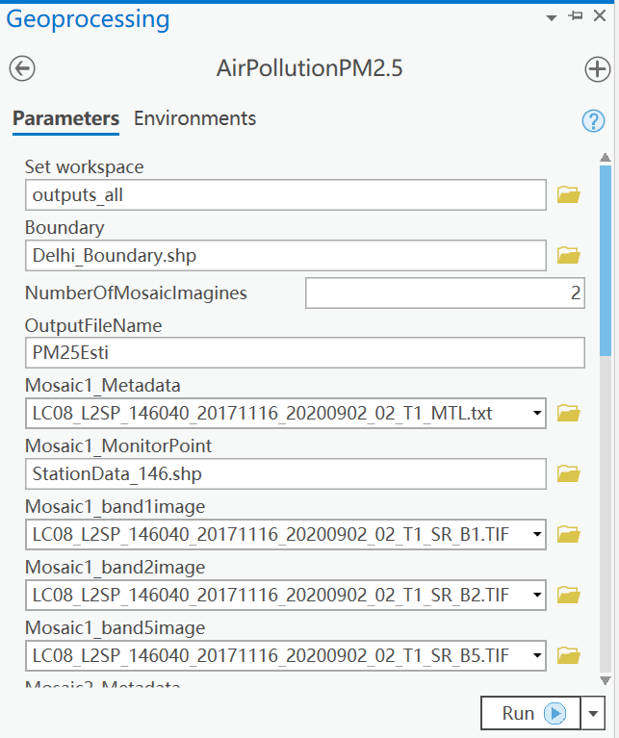

Produced on Nov16, 2017

Measured on Nov16, 2017

Produced on Nov16, 2017

2 image path146 & path147 cover study area, so NumberOfMosaicImagines is 2

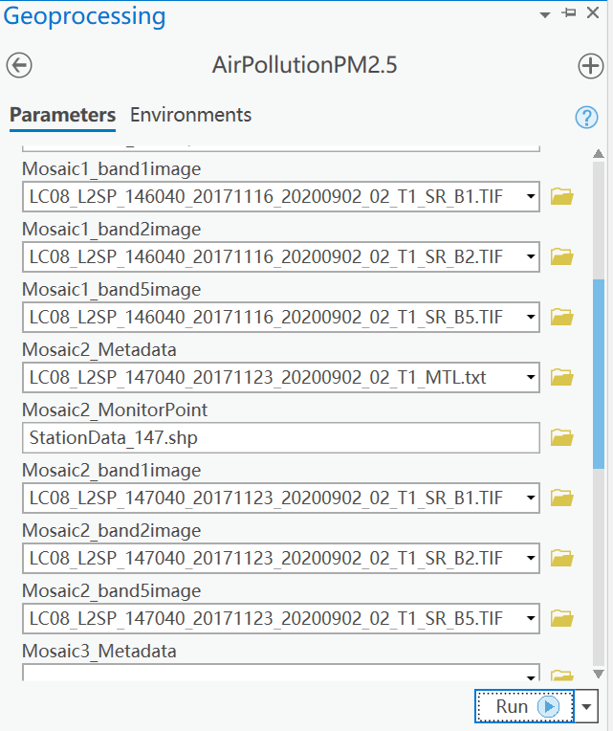

Produced on Nov23, 2017

Measured on Nov23, 2017

Produced on Nov23, 2017

***PM10:***

**Set workspace:** input a folder path to save output data

**Boundary:** input a path of polygon feature layer of study area. The study area of test data is Delhi (India). <https://github.com/datameet/Municipal_Spatial_Data/blob/master/Delhi/Delhi_Boundary-SHP.zip>

**NumberOfMosaicImages:** input how many satellite images will be mosaicked. In test data, Delhi is covered by 2 Landsat 8 images ---path146row40 and path147row40, so this parameter is 2.

**OutputFileName:** input an unoccupied folder name to store output raster file, this folder will be created under the path of workspace.

**Mosaic1_Metadata:** input text file path of the first satellite image metadata. Here it is the metadata of path146row40 Landsat 8 image, which was produced on Nov16,2017. <https://earthexplorer.usgs.gov/>

**Mosaic1_MonitorPoint:** input a path of point feature class which includes the location of each monitoring station and PM10 concentration ground truth data. Air pollutant ground truth data in most area of the world can be found at <https://aqicn.org/data-platform/register/>. Users should download the ground truth data and create point layer by themselves. The test data includes 15 monitoring stations in Delhi, PM10 concentration was measured on Nov16, 2017, which is same as satellite data.

**Mosaic1_band2image, Mosaic1_band3image, Mosaic1_band4image:** band 2,3,4 of the first Landsat 8 image. Test data are band 2,3,4 of path146row40 image, produced on Nov16, 2017. <https://earthexplorer.usgs.gov/>.

**Mosaic2_Metadata:** input text file path of the second satellite image metadata. Here it is the metadata of path147row40 Landsat 8 image, which was produced on Nov23,2017. If users have only one satellite image this parameter can be omitted. <https://earthexplorer.usgs.gov/>

**Mosaic2_MonitorPoint:** input a path of point feature class which includes the location of each monitoring station and PM10 concentration ground truth data. Air pollutant ground truth data in most area of the world can be found at <https://aqicn.org/data-platform/register/>. Users should download the ground truth data and create point layer by themselves. The test data includes 15 monitoring stations in Delhi, PM10 concentration was measured on Nov23, 2017, which is same as satellite data. If users have only one satellite image it can be omitted.

**Mosaic2_band2image, Mosaic2_band3image, Mosaic2_band4image:** band 2,3,4 of the second Landsat 8 image. Test data are band 2,3,4 of path147row image produced on Nov23, 2017. If users have only one satellite image these parameters can be omitted. <https://earthexplorer.usgs.gov/>.

**Mosaic3_Metadata:** input text file path of the third satellite image metadata. No test data, if users have less than 3 satellite images it can be omitted.

**Mosaic3_MonitorPoint:** input a path of point feature class which includes the location of each monitoring station and PM10 concentration ground truth data. Air pollutant ground truth data in most area of the world can be found at <https://aqicn.org/data-platform/register/>. Users should download the ground truth data and create point layer by themselves. No test data, if users have less than 3 satellite images it can be omitted.

**Mosaic3_band1image, Mosaic3_band2image, Mosaic3_band5image:** band 2,3,4 of the third Landsat 8 image. No test data. If users have less than 3 satellite images these parameters can be omitted.

**Mosaic4_Metadata:** input text file path of the fourth satellite image metadata. No test data, if users have less than 4 satellite images it can be omitted.

**Mosaic4_MonitorPoint:** input a path of point feature class which includes the location of each monitoring station and PM10 concentration ground truth data. Air pollutant ground truth data in most area of the world can be found at <https://aqicn.org/data-platform/register/>. Users should download the ground truth data and create point layer by themselves. No test data, if users have less than 4 satellite images it can be omitted.

**Mosaic4_band2image, Mosaic4_band3image, Mosaic4_band4image:** band 2,3,4 of the fourth Landsat 8 image. No test data. If users have less than 4 satellite images these parameters can be omitted.

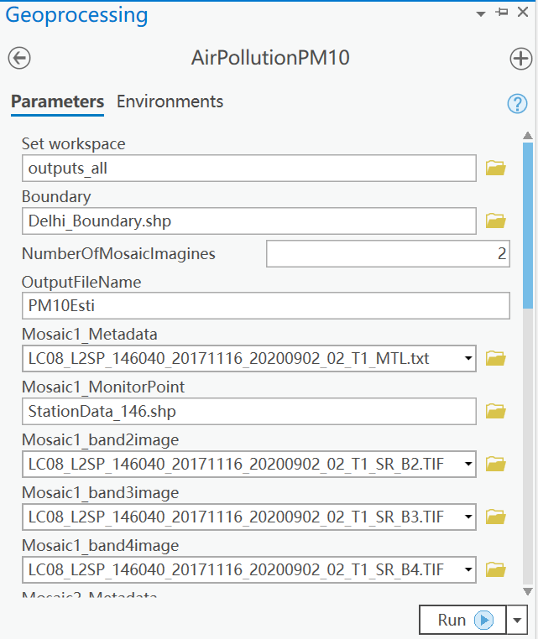

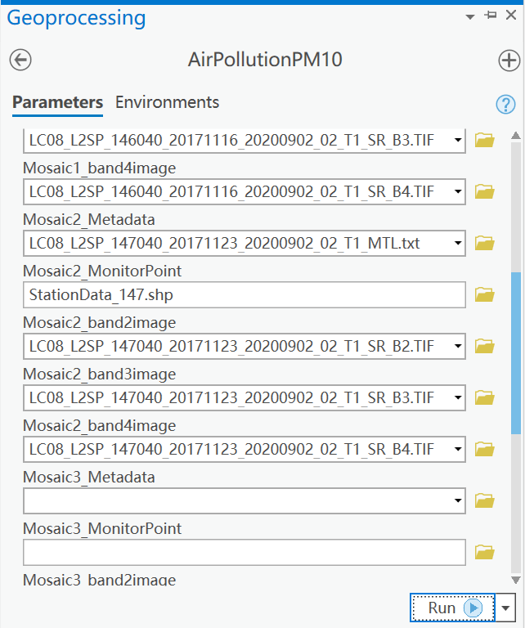

***Output:***

Air pollutant concentration estimation output for all images will be stored under OutputFileName folder. The final mosaic output is the first raster file in this folder. Raster file names are automatically created by system.

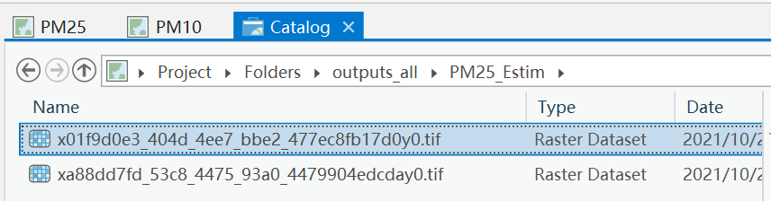

The first raster file the final mosaic output